**APEX COLLEGE**

**POKHARA UNIVERSITY**

**LAB REPORT OF**

**DOT NET TECHNOLOGY**

**LAB -1**

**Submitted By: Submitted To:**

**Remisha Maharjan Bishwomitra Adhikari**

**BCIS ‘Adware’ Ananta Pant**

**Roll no: 17**

**OBJECTIVE:-**

AN INTRODUCTION TO WEB API PART-1

**THEORY:-**

In computer programming, an application programming interface (API) is a set of subroutine definitions, protocols, and tools for building software and applications.

To put it in simple terms, API is some kind of interface which has a set of functions that allow programmers to access specific features or data of an application, operating system or other services.

Web API as the name suggests, is an API over the web which can be accessed using HTTP protocol. It is a concept and not a technology. We can build Web API using different technologies such as Java, .NET etc. For example, Twitter's [REST APIs](https://dev.twitter.com/rest/public) provide programmatic access to read and write data using which we can integrate twitter's capabilities into our own application.

**CODE:-**

1.Make a model

**Person.cs**

**using System;**

**namespace lab1_mvc.Models**

**{**

**public class Person**

**{**

**public string Name { get; set; }**

**public string Address{get;set;}**

**}**

**}**

2. In controller make an object to display your name and address.

**HomeController.cs**

**using System;**

**using System.Collections.Generic;**

**using System.Diagnostics;**

**using System.Linq;**

**using System.Threading.Tasks;**

**using Microsoft.AspNetCore.Mvc;**

**using lab1_mvc.Models;**

**namespace lab1_mvc.Controllers**

**{**

**public class HomeController : Controller**

**{**

**public IActionResult Index()**

**{**

**var model=new Person();**

**model.Name="Remisha";**

**model.Address="Rabi Bhawan";**

**// ViewBag.Name=model.Name;**

**// ViewBag.Address=model.Address;**

**return View(model);**

**}**

**public IActionResult Privacy()**

**{**

**return View();**

**}**

**[ResponseCache(Duration = 0, Location = ResponseCacheLocation.None, NoStore = true)]**

**public IActionResult Error()**

**{**

**return View(new ErrorViewModel { RequestId = Activity.Current?.Id ?? HttpContext.TraceIdentifier });**

**}**

**}**

**}**

3. Showing the output in the view

**Index.cshtml**

**@model lab1_mvc.Models.Person**

**@{**

**ViewData["Title"] = "Home Page";**

**}**

**<div class="text-center">**

**<h1 class="display-4">Welcome</h1>**

**<p>Learn about <a href="https://docs.microsoft.com/aspnet/core">building Web apps with ASP.NET Core</a>.</p>**

**</div>**

**<p>@Model.Name</p>**

**<p>@Model.Address</p>**

**@* <p>**

**Name:@ViewBag.Name**

**Address:@ViewBag.Address**

**</p> *@**

**OUTPUT:**

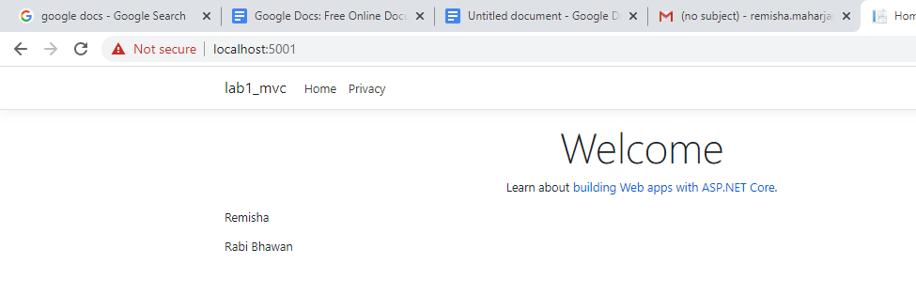

**CONCLUSION**

In lab1, we learned the basic way of using MVC in dot net technology.